SOUTHERN CROSS UNIVERSITY
ASSIGNMENT COVER SHEET
For use with online submission of assignments

Please complete all of the following details and then make this sheet the first page of each file of your assignment – do not send it as a separate document.

Your assignments must be submitted as either Word documents, text documents with .rtf extension or as .pdf documents. If you wish to submit in any other file format please discuss this with your lecturer well before the assignment submission date.

Student Name:
Student ID No.:
Unit Name: | Developing the User Experience
Unit Code: | PROG2001
Tutor’s name:
Assignment No.: | Assignment 2
Assignment Title:
Due date:
Date submitted:

Declaration:

I have read and understand the Rules Relating to Awards (Rule 3 Section 18 – Academic Misconduct Including Plagiarism) as contained in the SCU Policy Library. I understand the penalties that apply for plagiarism and agree to be bound by these rules. The work I am submitting electronically is entirely my own work.
Signed:
(please type your name)

Date:

Contents
SOUTHERN CROSS UNIVERSITY 1
Mood board / Style Tile 2
Storyboards 3
Technical Specifications 7
Git Commit Screenshots 7
UI Feedback 7
UI discussion and interaction screenshots 7
Collaboration Comments/Feedback 7
Media/Resources 7
References 7

Mood board / Style Tile

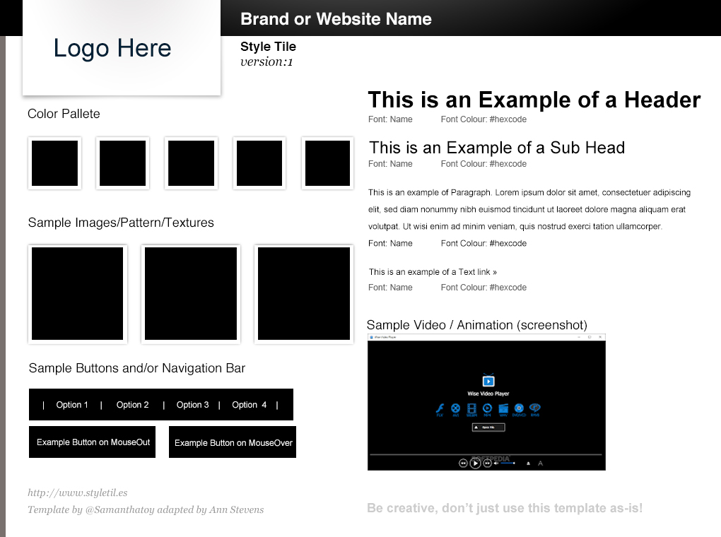

Storyboards
Title: Main Menu Frame ID: Menu
Main Menu
DESCRIPTION
CONTENT
BACKGROUND
USER FEEDBACK
REQUIRED INTERACTIONS
Navigation/Links
MEDIA RECORD
SOUNDS
IMAGES/FBX
BUTTONS
ANIMATION

Title: Scene 1 Frame ID: Scene 1
DESCRIPTION
CONTENT
BACKGROUND
USER FEEDBACK
game.
REQUIRED INTERACTIONS
Navigation/Links
MEDIA RECORD
SOUNDS
IMAGES/FBX ASSETS
ANIMATION

Technical Specifications

Git Commit Screenshots

UI Feedback
Assignment Link for assignment 2 on itch.io:

UI discussion and interaction screenshots

Collaboration Comments/Feedback

Media/Resources

References

